Greetings dear judges, sorry for the inconvenience.
To make sure the code works properly, please follow these instructions:
- Download the attached.py file and move it to your mu_code folder.
- Download the attached folder titled JCL and move it to your mu_code folder's image folder.
- Open the .py you just downloaded through Mu and please take note regarding this part:
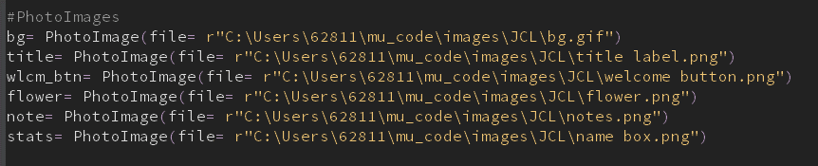
- That is the file directory of the image used, and unfortunately, once downloaded in a different computer, the directory will change, hence making the code not work.
- Therefore please change the file directory to suit your computer’s filing.
- You can find the file directory here:
- 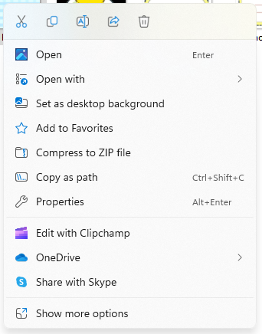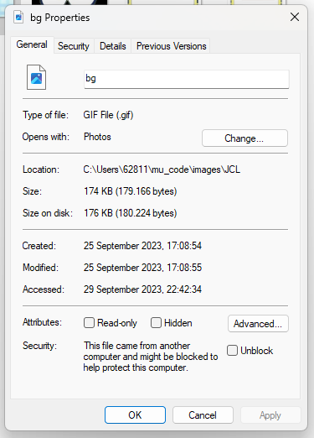
- Once you find that, you can copy and paste it to replace the one in the code
- Next, run the code to see if it works, if it doesn’t please inform me
Thank you very much for reading through this. Once again, I’m very sorry for the inconvenience. I hope everything works well.
Once again, thank you.
Sincerely,
Carla

